What the Customer Service Exam Looks Like and Functions
To the left side is the test timer. You get 1 hour and 30 minutes to complete your test. The left-hand side also shows how many questions you have not answered, how many you have complete, and the number you have flagged (marked so you can come back to them).
To move from one question to the next or backwards, click the Previous
arrow or the Next arrow. You can also see the question #.

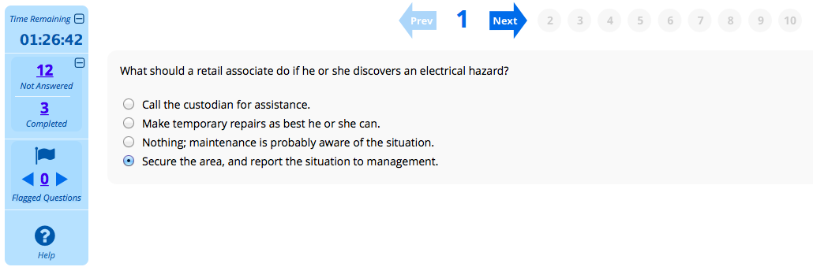
Read each question and click the circle in front of the response that you think is the correct one. When you’re ready to move on to the next question, click on the Next arrow at the top. A new screen with just 1 question will appear each time you hit the Next arrow.
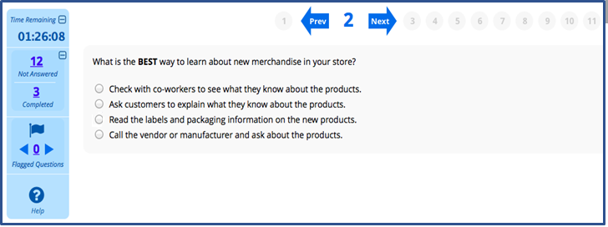
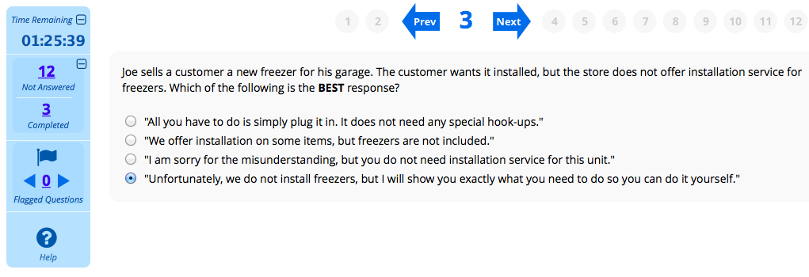

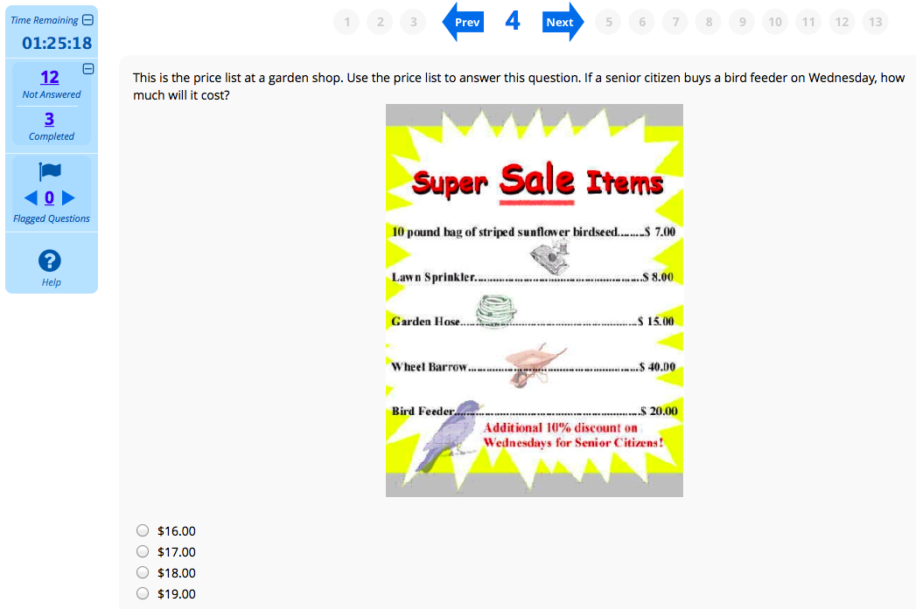

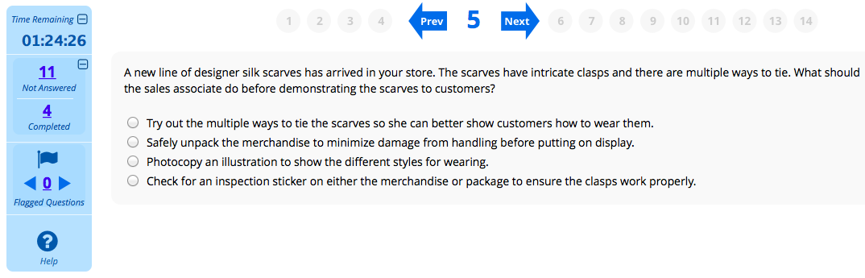

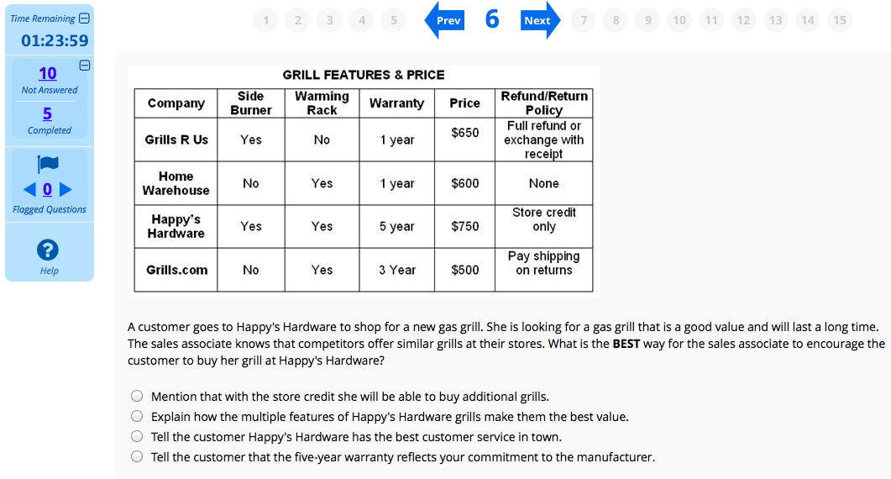

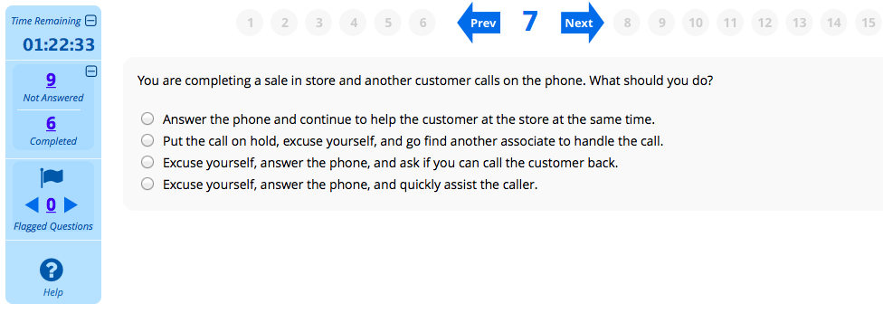
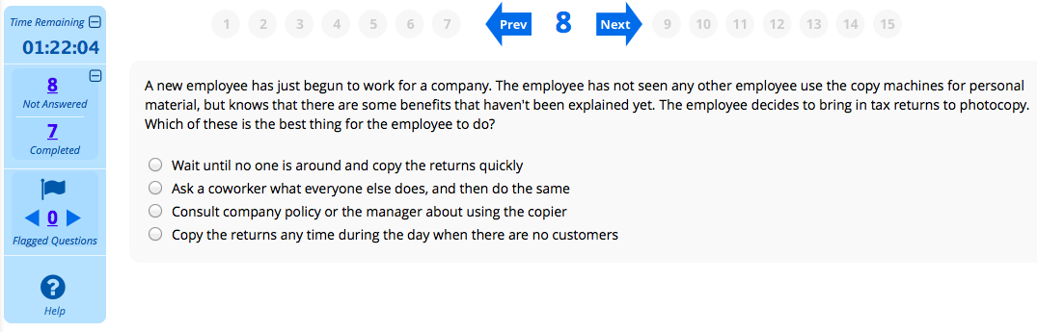
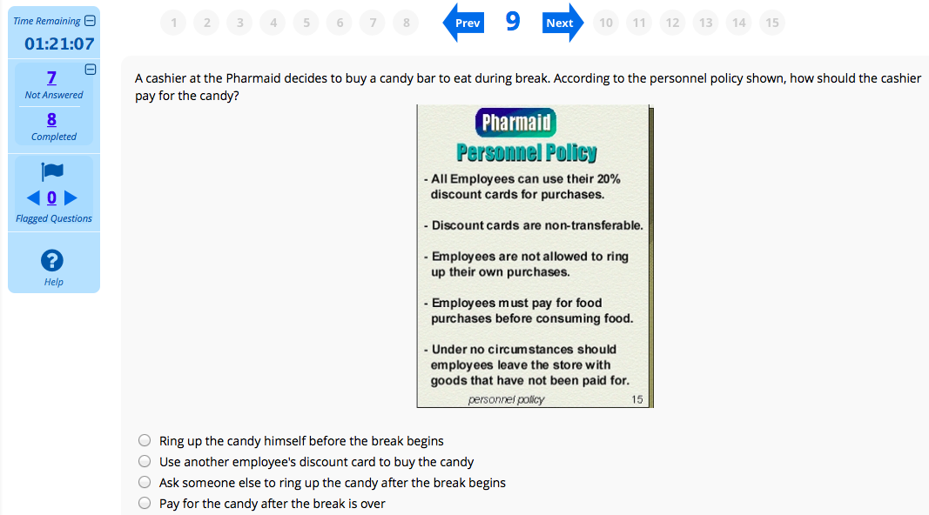
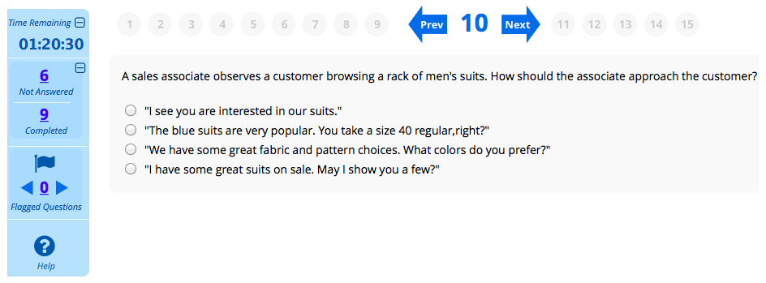
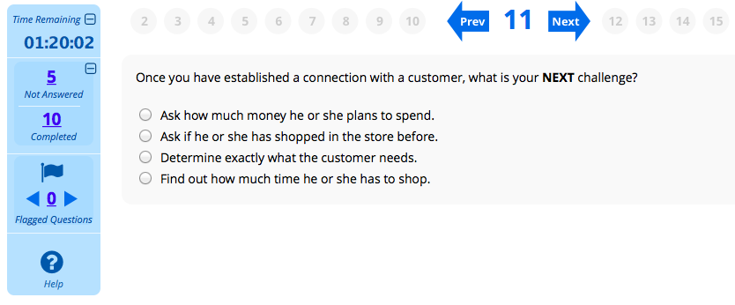
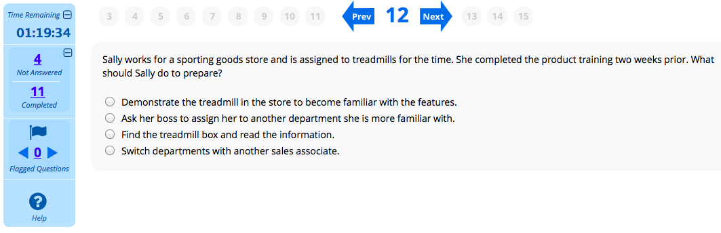

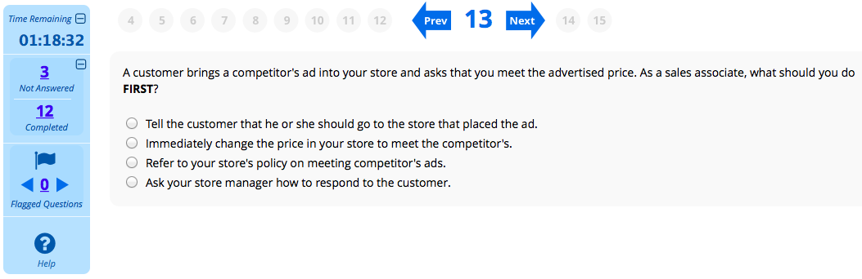
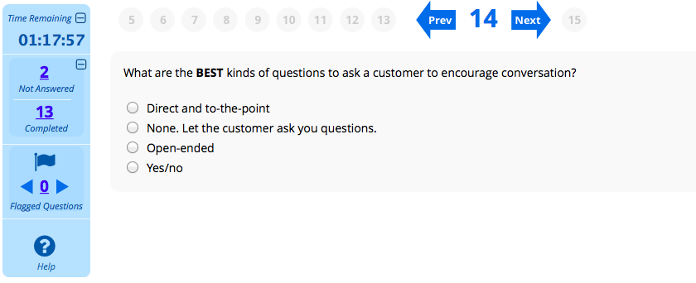
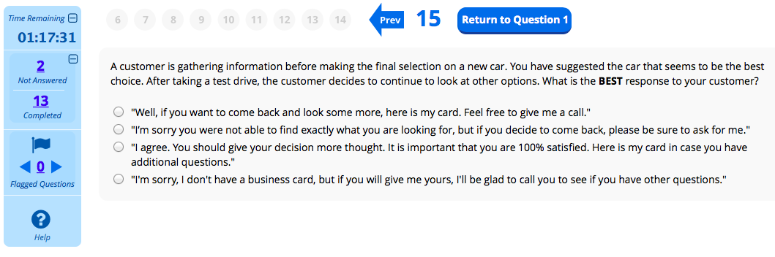
At the end of your 1 hour 30 minutes, your test will end automatically unless you finish earlier and submit it.
A survey will then appear on your screen. Once you finish the survey, you’ll see if you passed or failed the Customer Service Credential exam. Within 2 days, you will be emailed a link to your Customer Service Credential certificate. Make sure you print a copy of it and bring it to your teacher OR forward the link to your teacher. If your teacher does not get a copy of your certificate, it could affect your Jump Start completion which may affect your graduation.

