Answer Key found in Class Resources
1 | What should a retail associate do if he or she discovers an electrical hazard?
 | A | Call the custodian for assistance.
 | B | Make temporary repairs as best he or she can.
 | C | Nothing; maintenance is probably aware of the situation.
 | D | Secure the area, and report the situation to management.

2 | What is the BEST way to learn about new merchandise in your store?
 | A | Check with co-workers to see what they know about the products.
 | B | Ask customers to explain what they know about the products.
 | C | Read the labels and packaging information on the new products.
 | D | Call the vendor or manufacturer and ask about the products.

3 | Joe sells a customer a new freezer for his garage. The customer wants it installed, but the store does not offer installation service for freezers. Which of the following is the BEST response?
 | A | "All you have to do is simply plug it in. It does not need any special hook-ups."
 | B | "We offer installation on some items, but freezers are not included."
 | C | "I am sorry for the misunderstanding, but you do not need installation service for this unit."
 | D | "Unfortunately, we do not install freezers, but I will show you exactly what you need to do so you can do it yourself."

4 | This is the price list at a garden shop. Use the price list to answer this question. If a senior citizen buys a bird feeder on Wednesday, how much will it cost? (go to next page)  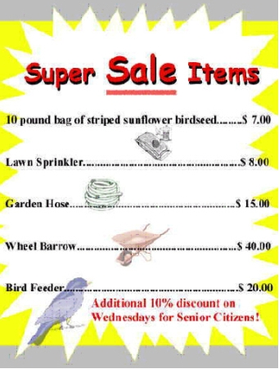
 | A | $16.00
 | B | $17.00
 | C | $18.00
 | D | $19.00

5 | A new line of designer silk scarves has arrived in your store. The scarves have intricate clasps and there are multiple ways to tie. What should the sales associate do before demonstrating the scarves to customers?
 | A | Try out the multiple ways to tie the scarves so she can better show customers how to wear them.
 | B | Safely unpack the merchandise to minimize damage from handling before putting on display.
 | C | Photocopy an illustration to show the different styles for wearing.
 | D | Check for an inspection sticker on either the merchandise or package to ensure the clasps work properly.

6 | 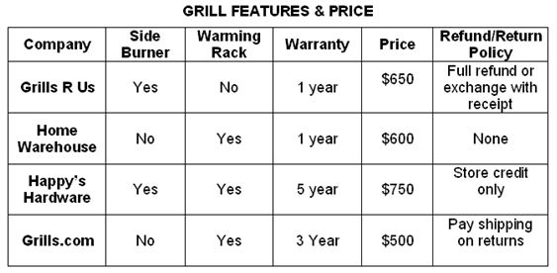  A customer goes to Happy's Hardware to shop for a new gas grill. She is looking for a gas grill that is a good value and will last a long time. The sales associate knows that competitors offer similar grills at their stores. What is the BEST way for the sales associate to encourage the customer to buy her grill at Happy's Hardware?
 | A | Mention that with the store credit she will be able to buy additional grills.
 | B | Explain how the multiple features of Happy's Hardware grills make them the best value.
 | C | Tell the customer Happy's Hardware has the best customer service in town.
 | D | Tell the customer that the five-year warranty reflects your commitment to the manufacturer.

7 | You are completing a sale in store and another customer calls on the phone. What should you do?
 | A | Answer the phone and continue to help the customer at the store at the same time.
 | B | Put the call on hold, excuse yourself, and go find another associate to handle the call.
 | C | Excuse yourself, answer the phone, and ask if you can call the customer back.
 | D | Excuse yourself, answer the phone, and quickly assist the caller.

8 | A new employee has just begun to work for a company. The employee has not seen any other employee use the copy machines for personal material, but knows that there are some benefits that haven't been explained yet. The employee decides to bring in tax returns to photocopy. Which of these is the best thing for the employee to do?
 | A | Wait until no one is around and copy the returns quickly
 | B | Ask a coworker what everyone else does, and then do the same
 | C | Consult company policy or the manager about using the copier
 | D | Copy the returns any time during the day when there are no customers

9 | A cashier at the Pharmaid decides to buy a candy bar to eat during break. According to the personnel policy shown, how should the cashier pay for the candy?  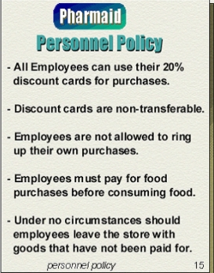
 | A | Ring up the candy himself before the break begins
 | B | Use another employee's discount card to buy the candy
 | C | Ask someone else to ring up the candy after the break begins
 | D | Pay for the candy after the break is over

10 | A sales associate observes a customer browsing a rack of men's suits. How should the associate approach the customer?
 | A | "I see you are interested in our suits."
 | B | "The blue suits are very popular. You take a size 40 regular,right?"
 | C | "We have some great fabric and pattern choices. What colors do you prefer?"
 | D | "I have some great suits on sale. May I show you a few?"

11 |  | Once you have established a connection with a customer, what is your NEXT challenge?
 |  | A |  | Ask how much money he or she plans to spend.
 |  | B |  | Ask if he or she has shopped in the store before.
 |  | C |  | Determine exactly what the customer needs.
 |  | D |  | Find out how much time he or she has to shop.
12 | Sally works for a sporting goods store and is assigned to treadmills for the time. She completed the product training two weeks prior. What should Sally do to prepare?
 | A |  | Demonstrate the treadmill in the store to become familiar with the features.
 | B |  | Ask her boss to assign her to another department she is more familiar with.
 | C |  | Find the treadmill box and read the information.
 | D |  | Switch departments with another sales associate.

13 | A customer brings a competitor's ad into your store and asks that you meet the advertised price. As a sales associate, what should you do FIRST?
 | A | Tell the customer that he or she should go to the store that placed the ad.
 | B | Immediately change the price in your store to meet the competitor's.
 | C | Refer to your store's policy on meeting competitor's ads.
 | D | Ask your store manager how to respond to the customer.

14 | What are the BEST kinds of questions to ask a customer to encourage conversation?
 | A | Direct and to-the-point
 | B | None. Let the customer ask you questions.
 | C | Open-ended
 | D | Yes/no

15 | A customer is gathering information before making the final selection on a new car. You have suggested the car that seems to be the best choice. After taking a test drive, the customer decides to continue to look at other options. What is the BEST response to your customer?
 | A | "Well, if you want to come back and look some more, here is my card. Feel free to give me a call."
 | B | "I’m sorry you were not able to find exactly what you are looking for, but if you decide to come back, please be sure to ask for me."
 | C | "I agree. You should give your decision more thought. It is important that you are 100% satisfied. Here is my card in case you have additional questions."
 | D | "I'm sorry, I don't have a business card, but if you will give me yours, I'll be glad to call you to see if you have other questions."

